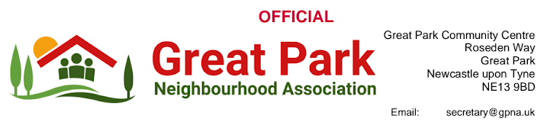

GPNA

Residents Survey Report & Feedback

2023 - 2024

484 residents participated in the GPNA survey, eager to share their vision for the Great Park Estate. This summary amplifies their voices, showcasing their priority concerns and concrete suggestions for those shaping the Estate's future.

Contents:
Page 3 | - Introduction: Great Park: A Community United for Improvement
Page 4 | Residents of Great Park: A summary of key concerns
Pages 5 - 6 | Communication
Pages 7 - 10 | - Great Park Service and Service Charge
Pages 11 - 12 | - Great Park Business
Pages 12 - 17 | - Safety on Great Park
Pages 17 - 18 | - Inclusion, Special Educational Needs and Disabilities
Pages 19 - 20 | - Adoption of the Great Park Estate
Page 21 | - GPNA aims and objectives
Pages 22 - 23 | - General Feedback
Pages 23 | - Summary of resident feedback for specific areas or facilities in Great Park that were believed to require improved maintenance or attention
Pages 23 - 25 | - Survey Report Conclusion and Recommended Next Steps

- Introduction: Great Park: A Community United for Improvement
Great Park, a vibrant residential estate in Newcastle, is home to a diverse community. Established in the early 2000s, the estate has grown rapidly, welcoming families, young professionals, and retirees alike. However, alongside its undeniable charms, Great Park has also faced its share of challenges.
This report, compiled from the voices of 484 residents who participated in the GPNA survey, aims to amplify their concerns and aspirations for the future of their estate.
Through open communication and a collaborative spirit, we believe that Great Park can reach its full potential. This report delves into the key areas where residents seek improvement, including:
- Communication and Transparency: Fostering a clearer dialogue between residents, the Consortium/management company, and local authorities.
- Service Charge and Accountability: Ensuring fair and transparent practices regarding the service charge, along with improved service delivery.
- Infrastructure Completion and Maintenance: Addressing unfinished infrastructure and prioritising preventative maintenance for a safe and accessible environment.
- Improved Public Transport and Town Centre Revitalization: Enhancing public transport connectivity and revitalising the town centre to create a thriving hub for the community.
- Safety and Security: Implementing measures to address speeding concerns, improve pedestrian infrastructure, and enhance safety in parks and play areas.
- Inclusion and Support for SEND Residents: Creating a welcoming and accessible environment for residents with special educational needs and disabilities.
This report is not merely a compilation of grievances; it is a testament to the resilience and dedication of the Great Park community. Residents' desire for a better future is palpable, and their voices deserve to be heard.
By acknowledging their concerns and working together towards solutions, we can transform Great Park into a true model community, where every resident feels valued, safe, and empowered to contribute to its continued growth and prosperity.
We invite you to join us on this journey, as we work to build a brighter future for Great Park, one step at a time.
This report serves as a call to action, not just for the Consortium/management company and local authorities, but for every resident. By embracing shared responsibility and a collaborative spirit, we can unlock the immense potential of Great Park and create a community that thrives for generations to come.
Let us move forward, united in our vision for a Great Park that is truly great for all.

Residents of Great Park: A summary of key concerns
Residents on Great Park have voiced strong dissatisfaction with several aspects of the estate, focusing on:
1. Lack of Transparency and Accountability:
- Feeling their service charge isn't delivering proper value.
- Unclear spending practices from the consortium managing the estate.
- Insufficient action from the council to hold the consortium responsible.
2. Unfinished Infrastructure:
- Incomplete roads and paths hindering accessibility, particularly for pedestrians and cyclists.
3. Poor Public Transport:
- Limited and unreliable public transport options, restricting residents' mobility.
4. Inadequate Street Lighting:
- Poorly lit streets creating safety concerns at night.
5. High Service Charges:
- Feeling burdened by high service charges despite lacking amenities and services.
Overall, residents feel neglected and frustrated by the current situation. Their main desires are increased transparency, completed infrastructure, improved public transport, better lighting, and a review of the service charge to ensure fairness.

- Communication
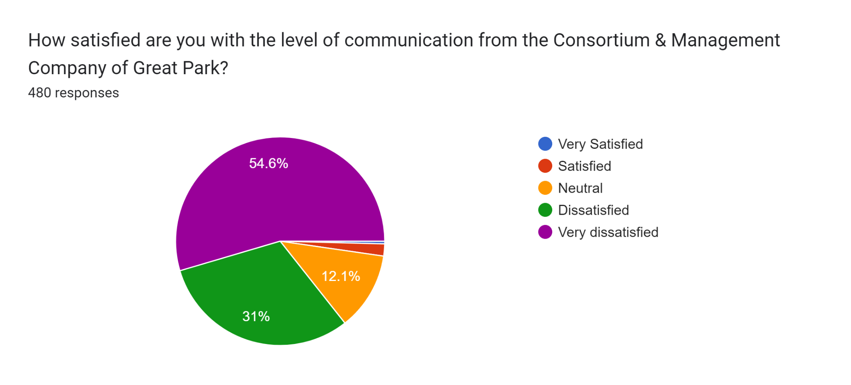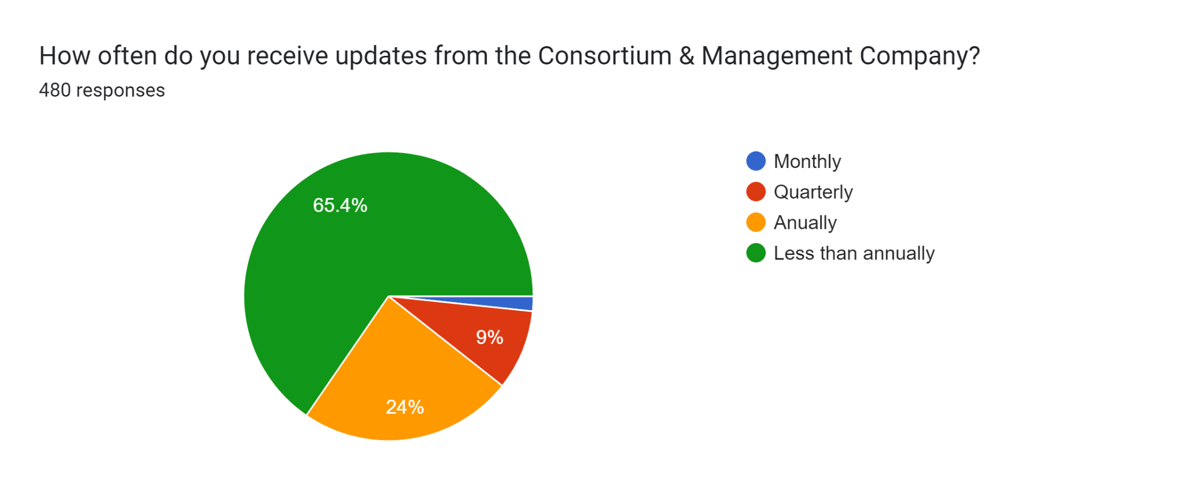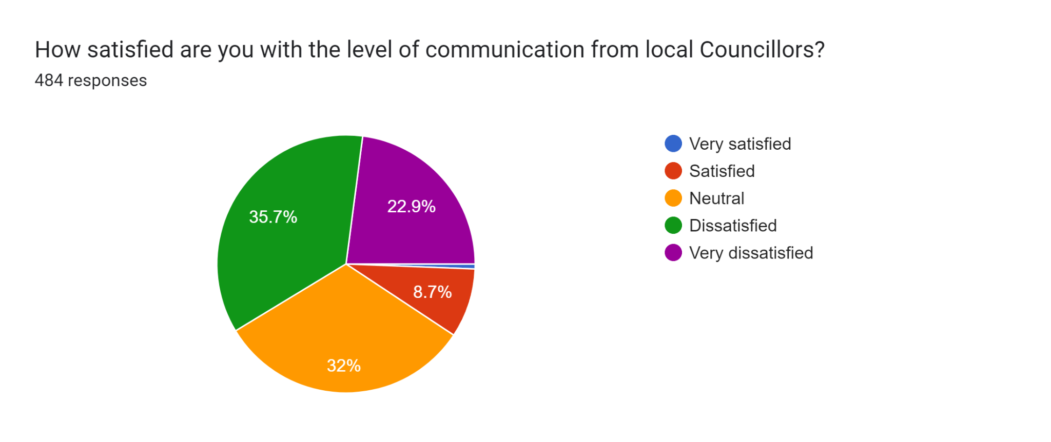
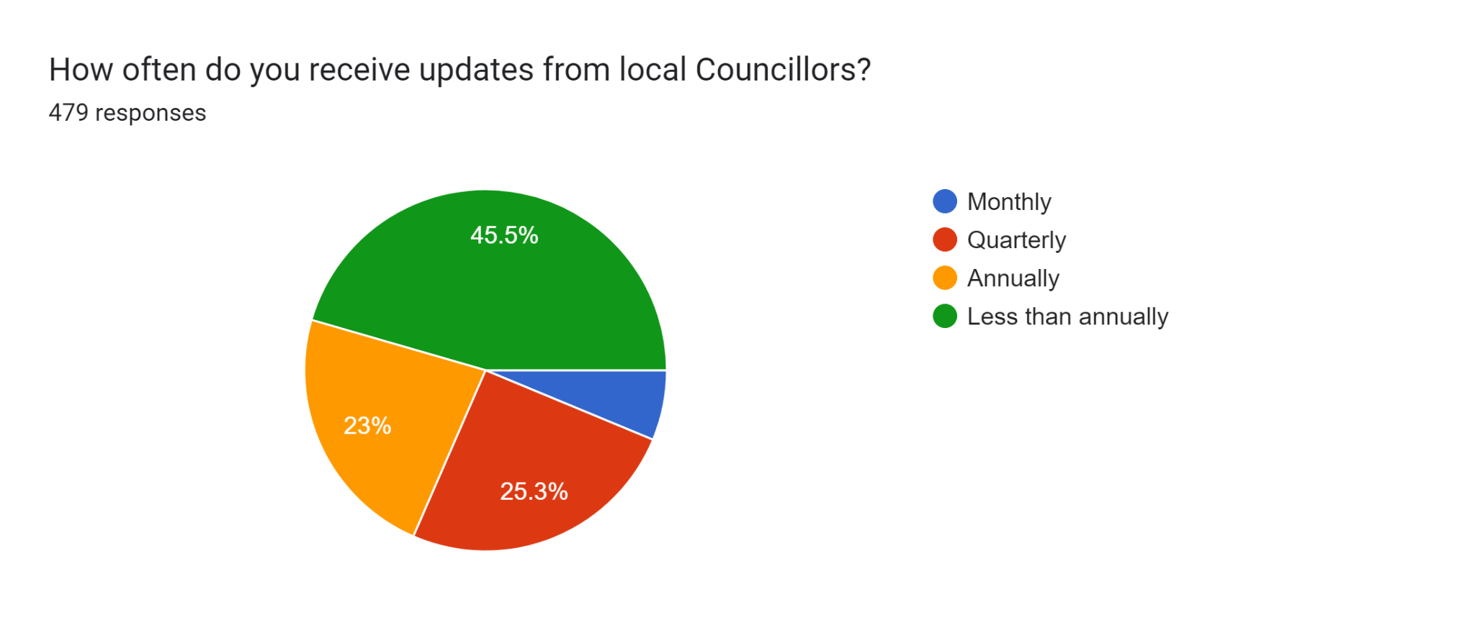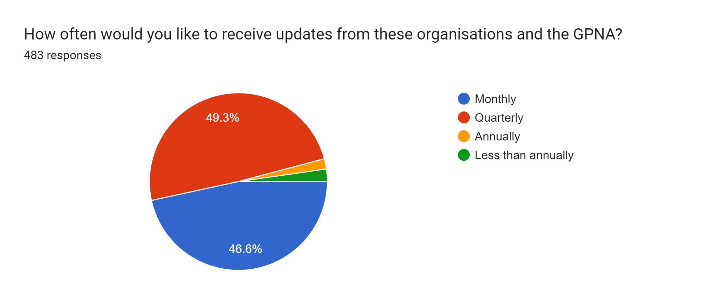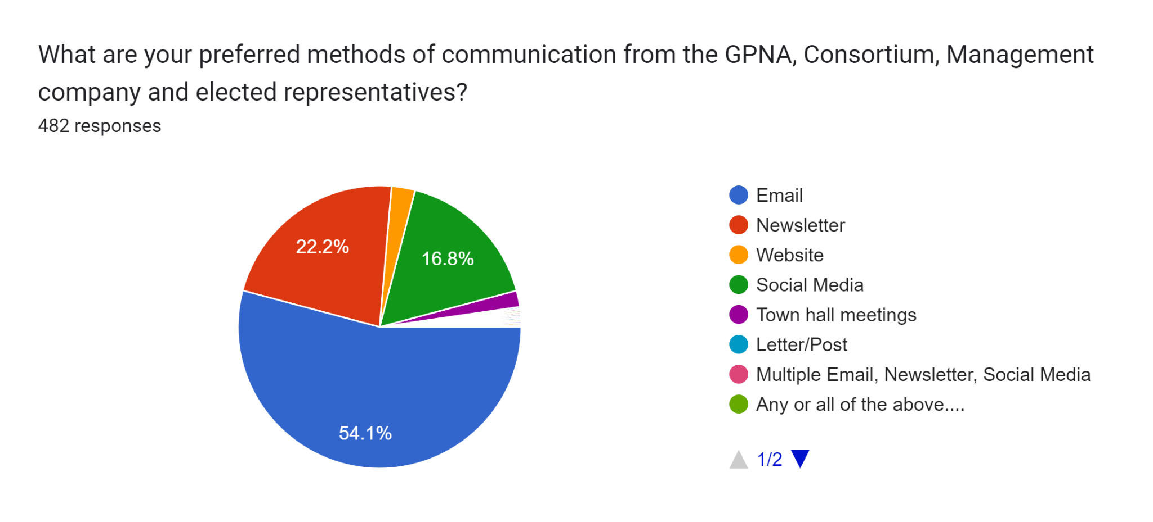

- Great Park Service and Service Charge
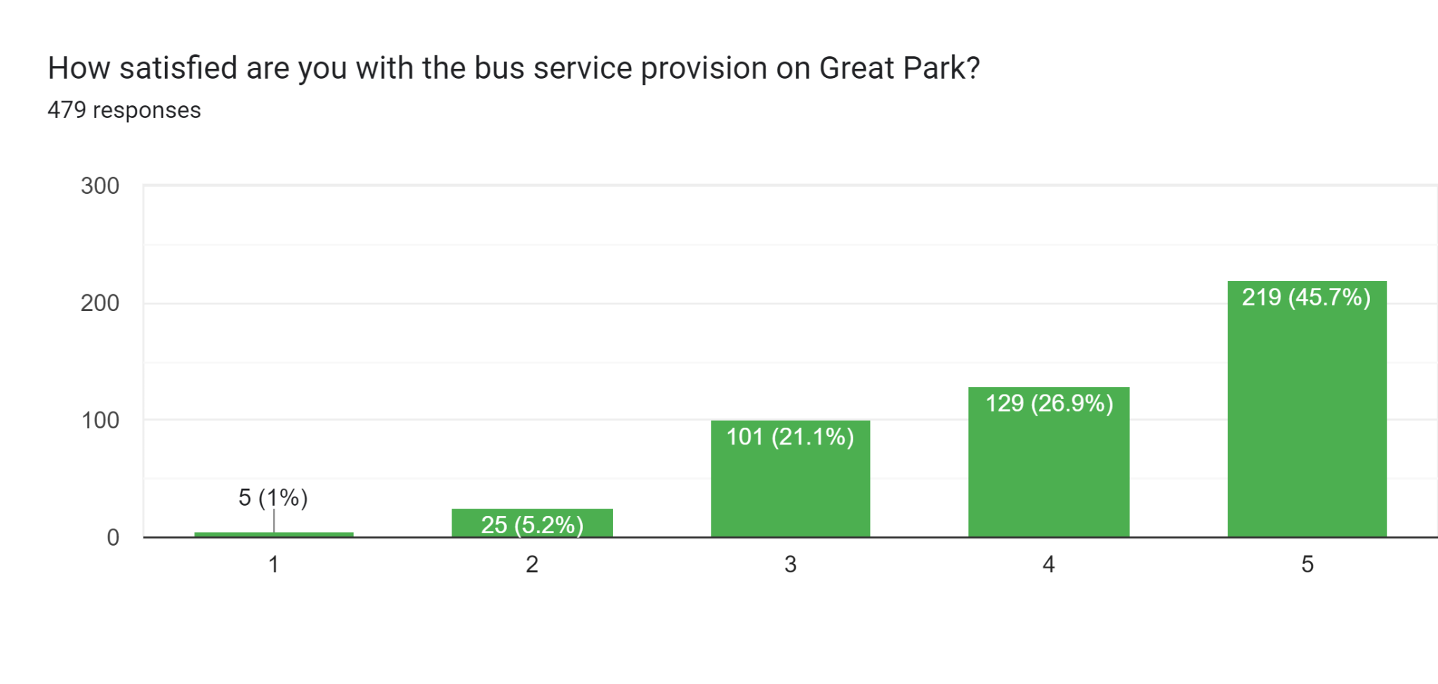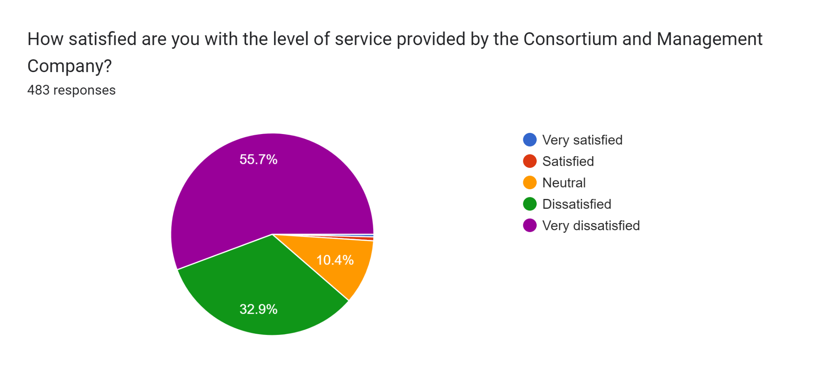
Summary feedback on what could the Consortium & Management company do to improve its service?
Main feedback themes:
- Communication: Be more responsive to requests, be more transparent in decision-making, and keep residents informed of progress.
- Accountability: Be more accountable to residents for service quality, financial transparency, and addressing concerns.
- Service provision: Provide more services, improve existing services, and maintain the estate effectively.
- Specific issues: Several residents mentioned specific issues like unfinished work, potholes, lighting, and play areas.
Additional points:
- The role of the Consortium and Management company is not entirely clear to some residents.
- Some residents feel the service charges are too high and not justified by the level of service.
- There is a desire for more community engagement and involvement in decision-making.
Overall:
There is a general feeling that the Consortium & Management company could improve its service to residents by being more communicative, accountable, and responsive to their needs.
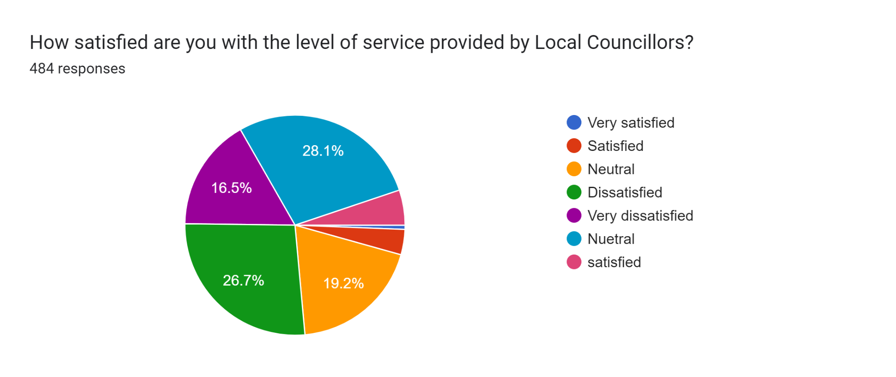

Summary of Feedback for Local Councillors:
Key Themes:
- Communication: Residents want more communication, including:
  - Responsiveness to requests: Residents want councillors to be more responsive to their inquiries and concerns.
  - Transparency in decision-making: Residents want to understand how decisions are made and the rationale behind them.
  - Regular updates: Residents want to be kept informed about progress on issues of concern.
- Accountability: Residents want councillors to be more accountable for their actions and the actions of the Consortium and management company. This includes:
  - Delivering on promises: Residents want to see results and improvements, not just empty promises.
  - Holding the Consortium and management company accountable: Residents feel the Consortium and management company are not providing adequate services and want councillors to do more to hold them accountable.
  - Taking action on resident concerns: Residents want councillors to actively address their concerns and not simply ignore them.
- Service Provision: Residents want to see improvements in service provision, including:
  - More services: Residents feel they are not getting enough value for their money and want to see more services provided.
  - Improved quality of existing services: Residents want to see existing services improve in terms of quality and efficiency.
  - Adoption of the estate: Residents want the estate to be adopted by the council so they don't have to pay additional fees.
Additional Points:
- Some residents are unaware of who their councillors are or how to contact them.
- Some residents feel that councillors are not effective or have little influence.
- There is a general feeling of distrust and dissatisfaction with the Consortium and management company.
Overall:
There is a clear need for local councillors to improve their communication, accountability, and service provision in order to regain the trust and confidence of residents.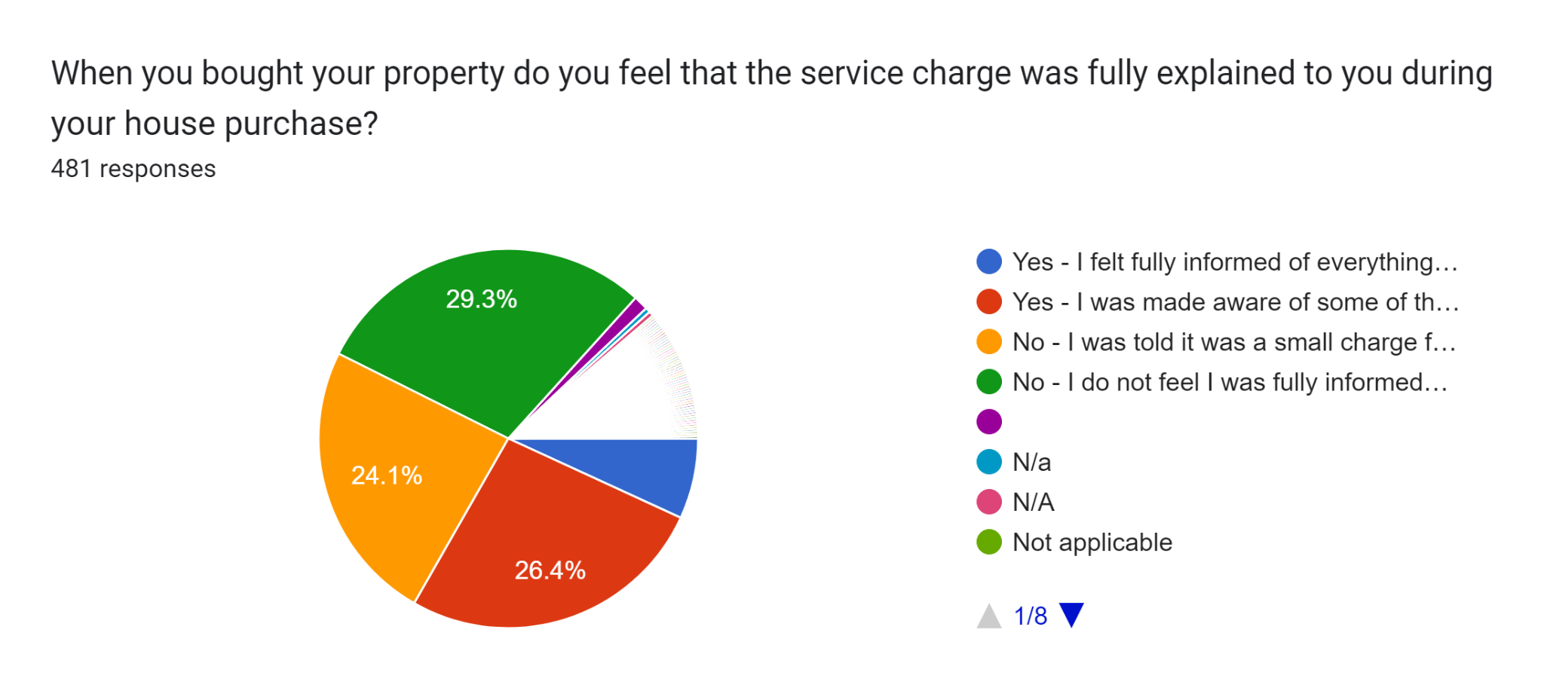
Key Findings:
- A significant majority of residents (over 80%) felt they were not fully informed about the service charge during their house purchase.
- Common reasons for feeling uninformed included:
  - Being told the charge was a small amount for basic services like grass cutting.
  - Not being made aware of the full range of services covered by the charge.
  - Lack of transparency about how the charge is used.
- Some residents also expressed concerns about:
  - The increasing cost of the service charge.
  - The lack of value for money they feel they are getting.
  - The accountability of the Consortium and management company.
Overall, there is a clear need for improved communication and transparency around the service charge in Great Park. Residents need to be fully informed about what the charge is for, how it is used, and how they can hold the Consortium and management company accountable.
Additional Points:
- A small number of residents (around 10%) felt they were fully informed about the service charge.
- Some residents who live on Melbury do not pay a service charge.
- There is some confusion about the future of the service charge, with some residents believing it will eventually be adopted by the council.
Recommendations:
- The Consortium and management company should develop a clear and concise explanation of the service charge, including what it is for, how it is used, and how residents can hold them accountable.
- This information should be provided to all residents, both existing and new, in a format that is easy to understand.
- The Consortium and management company should hold regular meetings with residents to answer questions and address concerns.
- Residents should be encouraged to get involved in decision-making about the service charge.

- Great Park Business
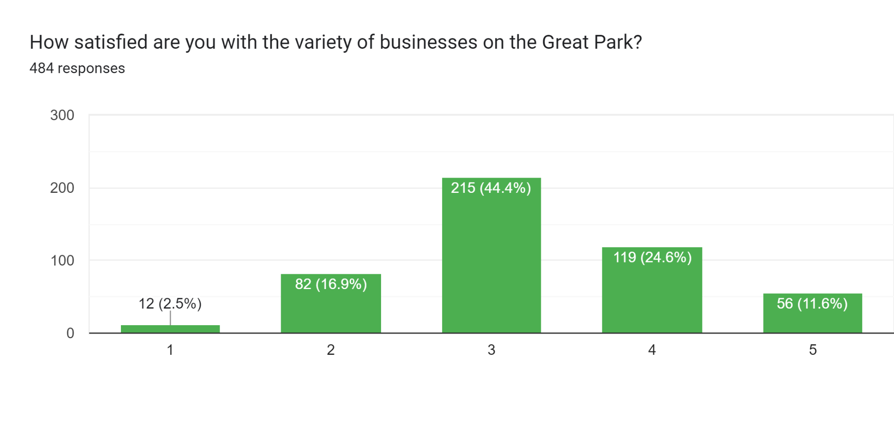
Summary of Suggestions for Improving Great Park Town Centre:
Key Themes:
- Fill empty units: This is the most common suggestion, with many residents mentioning the need for a variety of businesses, including restaurants, pubs, cafes, shops, and services like doctors, dentists, and a post office.
- Reduce rent: Many believe high rents are discouraging businesses from opening. Lowering rents or offering incentives is seen as a key way to attract new tenants.
- Improve appearance: Residents want the town centre to look cleaner, tidier, and more inviting. This includes repairs to the buildings, landscaping, and better maintenance of public spaces.
- More community facilities: Suggestions include a gym, leisure centre, pub, playground, and green spaces. These would make the town centre a more attractive place to spend time.
- Better transport and parking: Improved public transport links and more accessible parking would make it easier for people to visit the town centre.
Other suggestions:
- Fix the drainage problem near Morrisons.
- Improve signage to parking areas.
- Organise events and activities to attract people to the town centre.
- Encourage local businesses to open.
- Offer pop-up markets or temporary use of units to test new businesses.
- Improve public lighting and safety.
- Address concerns about the cost of service charge.
Overall, there is a clear desire from residents to see Great Park Town Centre become a more vibrant and thriving place. By addressing the key concerns and implementing the suggestions listed above, the town centre can become a valuable asset for the community.
- Safety on Great Park
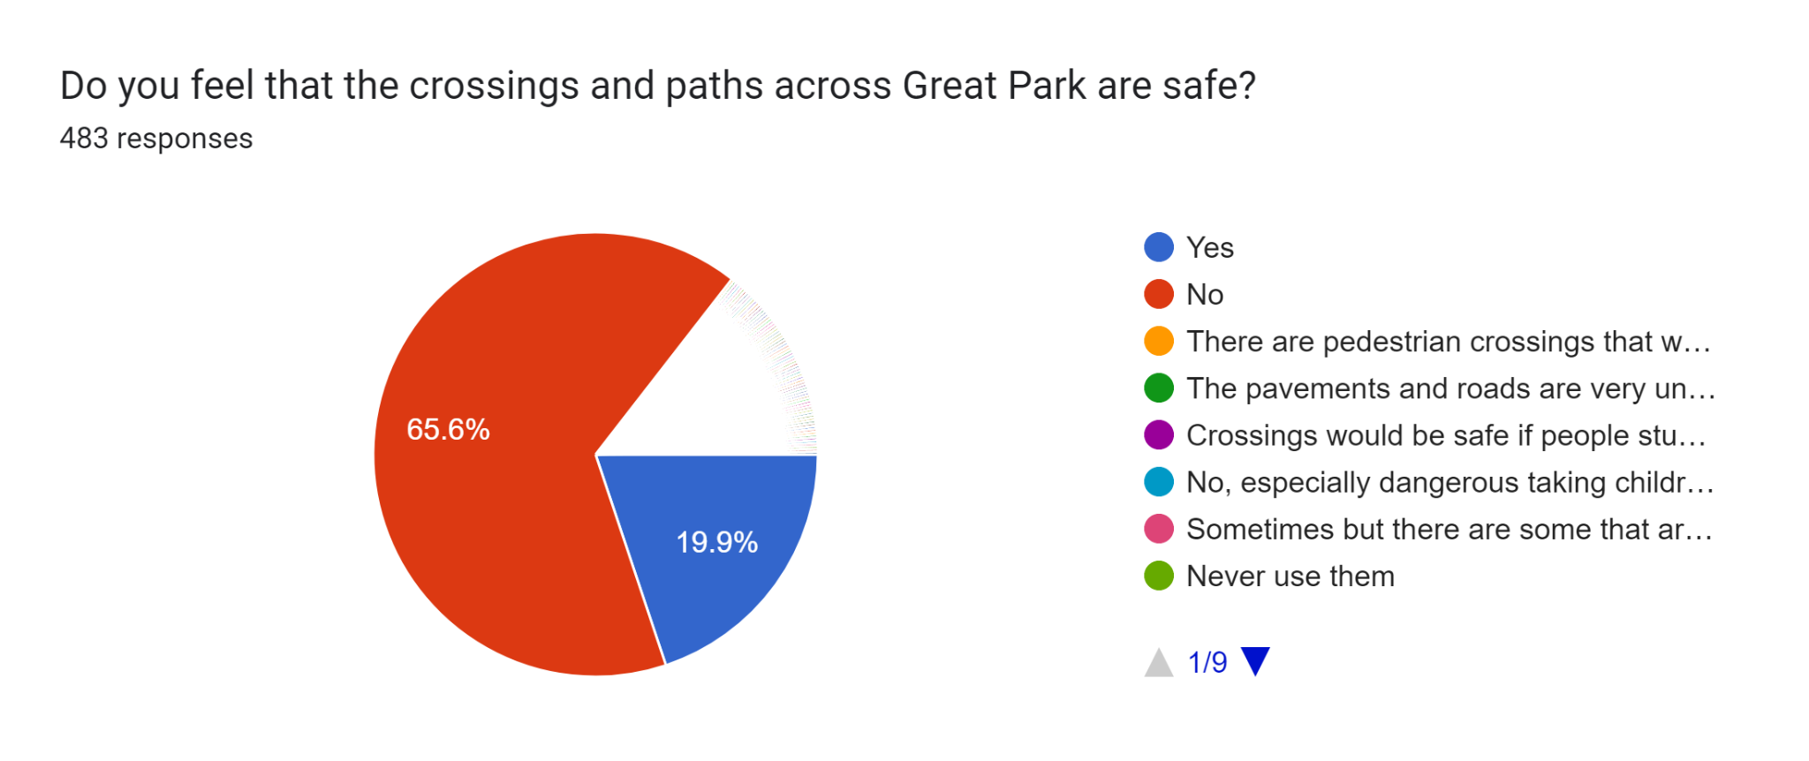

Summary of Resident Feedback on crossing and path safety in Great Park:
Overwhelming Concern: Residents expressed significant concerns about the safety of pedestrian infrastructure in Great Park.
Key Issues:
- Lack of Crossings: Numerous areas lack safe crossing points, particularly along busy roads like Roseden Way and Brunton Lane. This puts pedestrians at risk, especially children and elderly individuals.
- Incomplete Paths: Unfinished paths with uneven surfaces and missing sections create obstacles and tripping hazards, increasing the risk of falls and injuries.
- Poor Lighting: Inadequate street lighting creates visibility issues, especially at night, further aggravating safety concerns.
- Traffic Problems: Speeding vehicles and disregard for pedestrian right-of-way contribute to the overall danger on the roads.
- Specific Concerns:
  - The junction of Morrisons onto Roseden Way was highlighted as particularly dangerous due to its size and parked cars on corners.
  - The lack of traffic lights at the main roundabout poses a risk for pedestrians accessing the school.
  - Unfinished paths and uneven surfaces make using prams and wheelchairs difficult.

Suggestions for Improvement:
- Install well-marked and signalled crossings at key locations.
- Complete and resurface all footpaths to eliminate uneven surfaces and tripping hazards.
- Improve street lighting throughout the area.
- Implement traffic calming measures on busy roads to reduce speeding.
- Address specific concerns through additional signage, road markings, or traffic lights.
Overall Sentiment: Residents feel that the current state of pedestrian infrastructure in Great Park significantly compromises their safety and well-being. They urge prompt action to address these concerns and implement the suggested improvements to create a safer and more accessible environment for everyone.
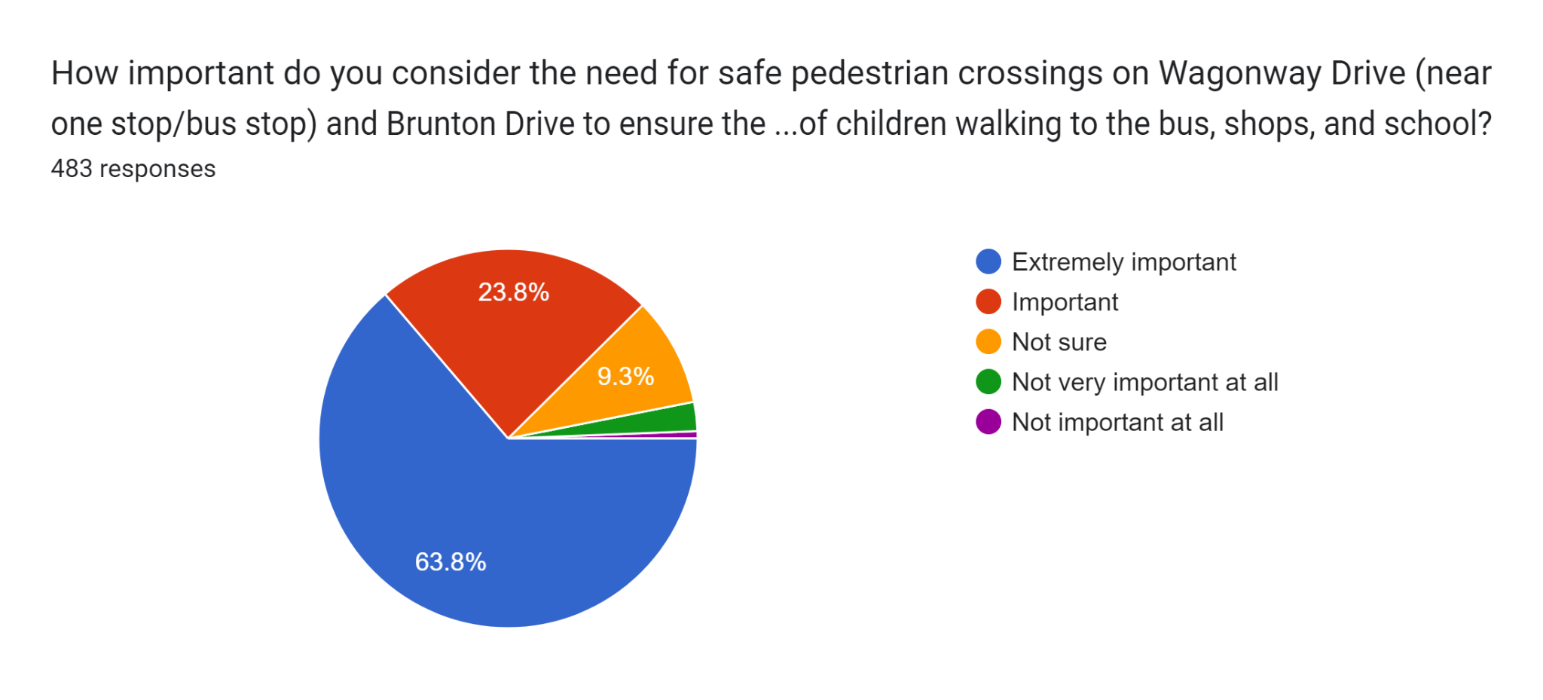
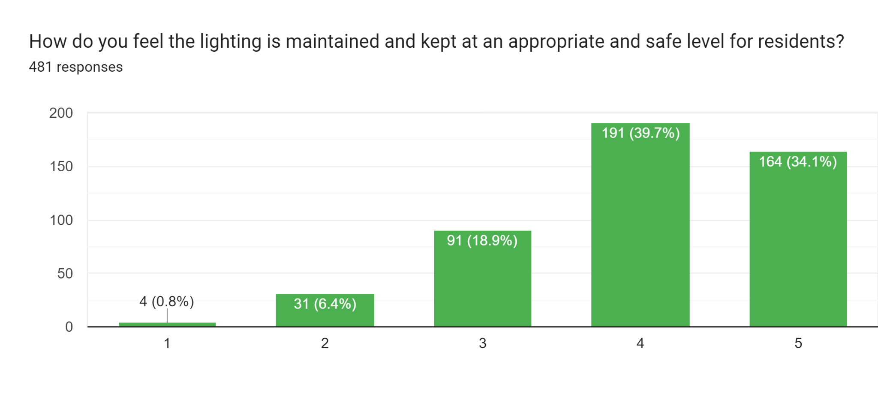
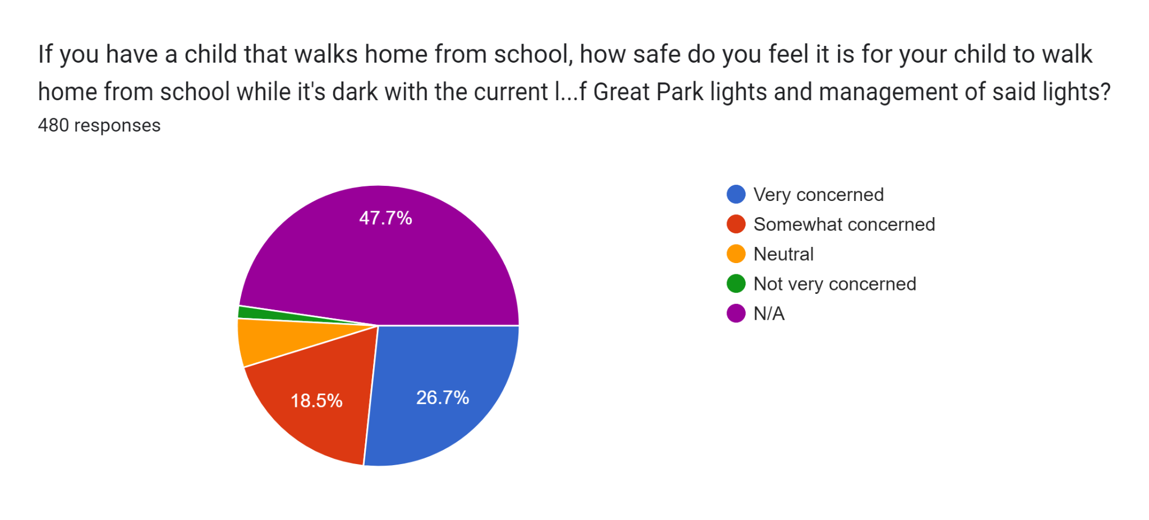
Summary of Resident Feedback on Safety Measures to Address Speeding:
Most Popular Measures:
- Traffic calming measures (speed bumps, speed humps): This was overwhelmingly the most frequently suggested measure, with residents believing it would effectively discourage speeding and make roads safer for pedestrians.
- Increased speed enforcement: Many residents called for more frequent and visible speed enforcement, such as through speed cameras or increased police patrols, to deter speeding and hold violators accountable.
- Improved street lighting: Improved lighting was seen as crucial for enhancing visibility, especially at night, to make drivers more aware of pedestrians and potential hazards.
- Additional signage: Clearer signage indicating speed limits, crossings, and other safety warnings was also considered important for reminding drivers to abide by the rules.
Other Notable Suggestions:
- Reduced speed limits on specific roads: Some residents proposed lowering speed limits on particular roads, such as Great Parkway, to 30 mph.
- Chicanes: A few residents suggested using chicanes (obstacles that force drivers to slow down) as an alternative to speed bumps.
- Yellow lines at corners: To prevent obstructed vision and traffic violations, residents suggested enforcing parking restrictions at corners.
- Deer signs: Highlighting the presence of deer could make drivers more cautious and reduce speeding risks.
- CCTV at crossings: Monitoring crossings near schools with CCTV could deter speeding and ensure pedestrian safety.

Key Considerations:
- Resident concerns about noise from speed bumps: Some residents expressed concerns about the potential noise pollution from speed bumps. Alternative traffic calming measures, such as chicanes or raised crosswalks, could be explored.
- Need for comprehensive approach: Residents emphasised that a combination of measures, rather than a single solution, would be most effective in addressing speeding concerns.
- Prioritising safety near schools: Ensuring safety around schools was a major priority for many residents, highlighting the need for enhanced measures in those areas.
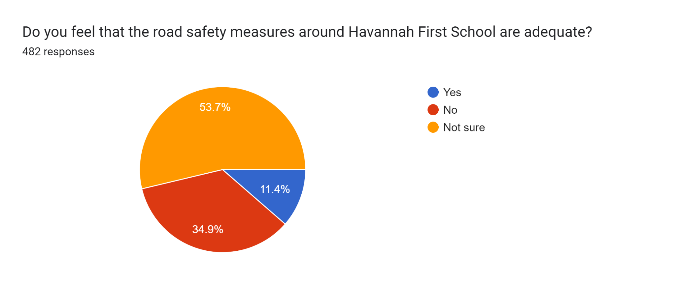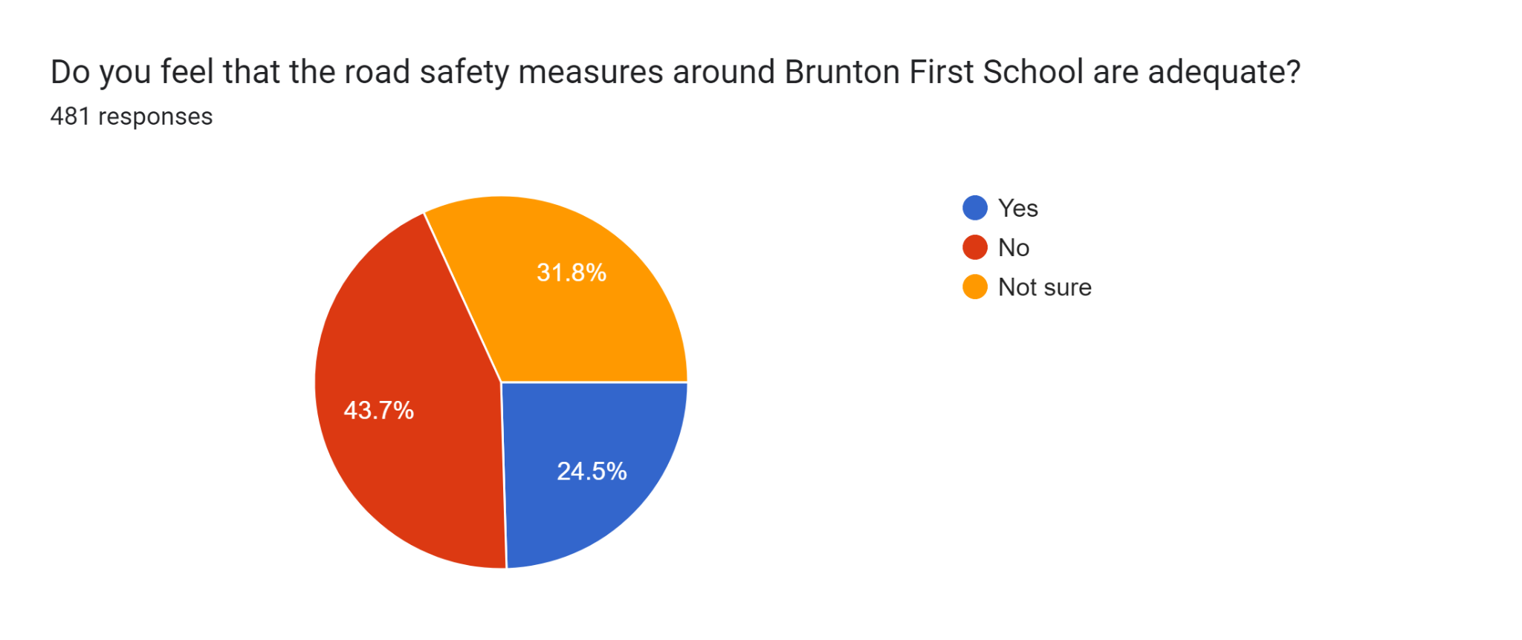

Based on residents feedback, several key themes emerged for what residents believed would enhance safety around Great Parks local schools:
Parking and congestion:
- Excessive parking on double yellow lines and pedestrian paths: This creates obstacles and safety hazards for children and pedestrians. Solutions include stricter enforcement of parking regulations, extending yellow lines, and creating designated drop-off areas.
- Traffic congestion during pick-up and drop-off times: Staggered school start/finish times, encouraging use of the park and ride, and improving pedestrian/cycling infrastructure could help alleviate congestion.
Pedestrian safety:
- Lack of safe crossing points and incomplete paths: Providing well-marked crossings, zebra crossings, and completing existing paths are crucial for safe pedestrian movement.
- Speeding traffic: Implementing traffic calming measures like speed bumps, chicanes, and increased speed enforcement is essential to slow down vehicles near schools.
- Visibility issues: Improved lighting, clear signage, and removing parked cars obstructing views can enhance visibility for both pedestrians and drivers.
Additional concerns:
- Safety fencing near the wood at Havannah: Addressing this potential hazard with fencing and warning signs is important.
- Construction traffic: Diverting construction traffic away from school hours and prioritising pedestrian safety near building zones is crucial.
- Irresponsible parking by parents: Public awareness campaigns and stricter enforcement can address inconsiderate parking behaviour.
Overall, implementing a combination of these measures, tailored to the specific needs of each school and its surroundings, would significantly improve safety for students, staff, and the wider community. It is important to involve all stakeholders, including school administrators, residents, and local authorities, in developing and implementing effective safety measures.
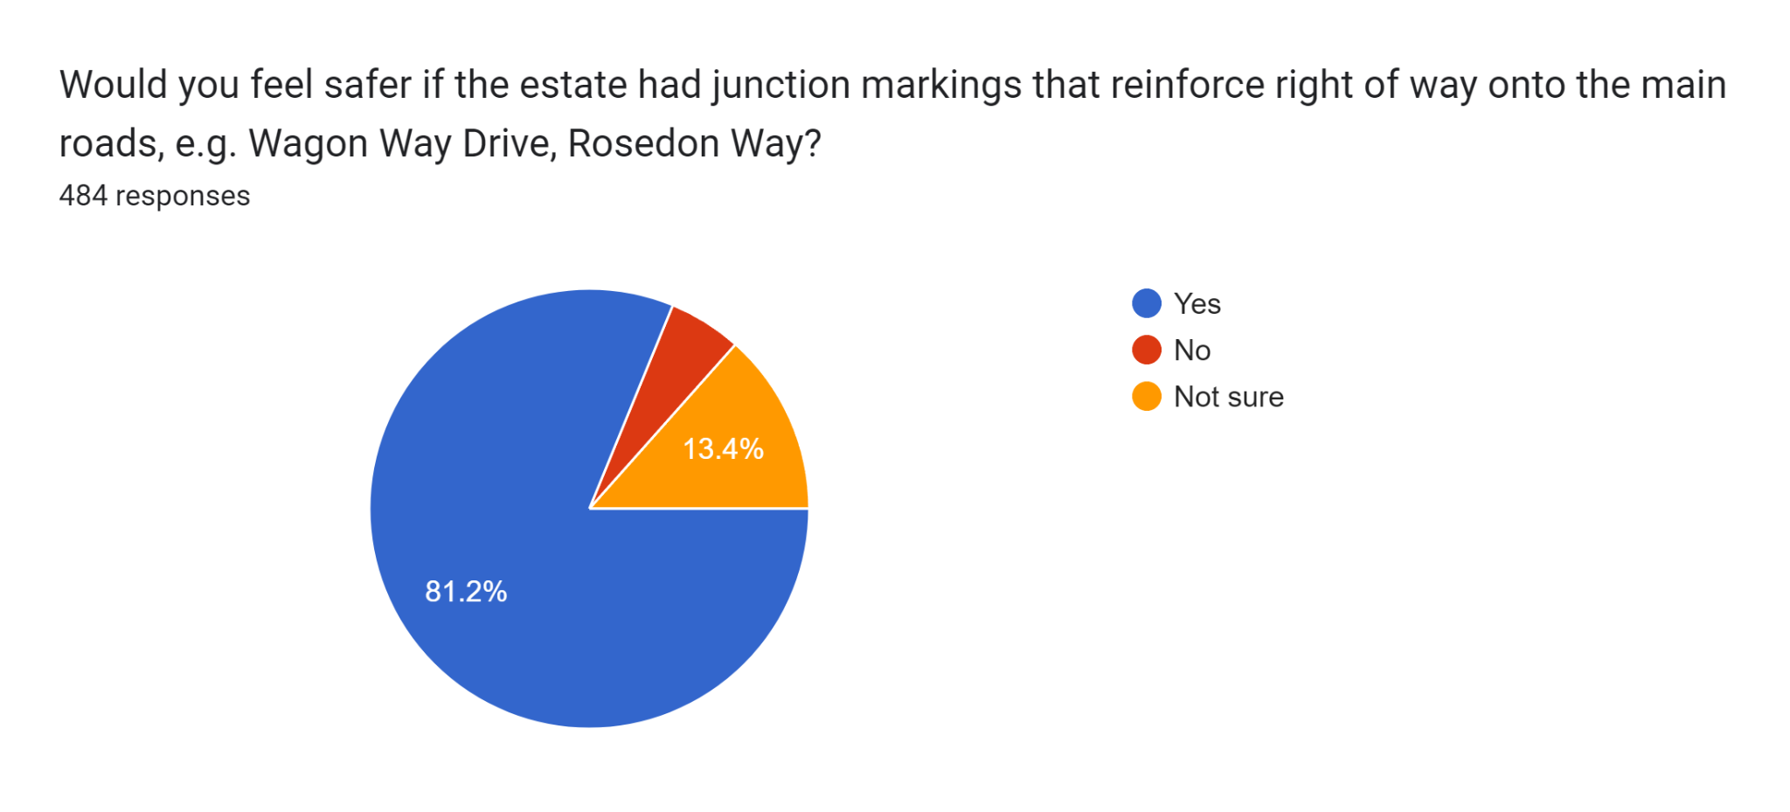
7. Inclusion, Special Educational Needs and Disabilities
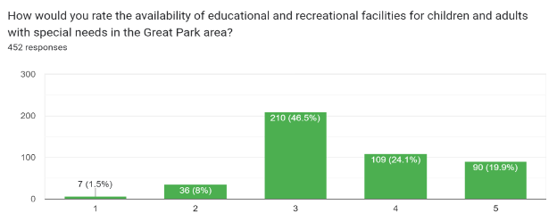
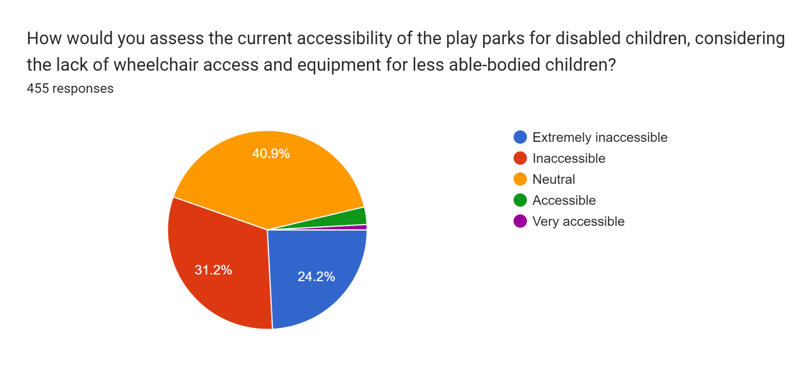
Resident feedback highlighted several key areas for improvement:
Accessibility:
- Accessible paths and crossings: Smooth, well-maintained paths with lowered curbs and proper drop kerbs are crucial for wheelchair users and individuals with mobility challenges.
- Accessible play equipment: Parks need inclusive equipment that caters to children of all abilities, including wheelchair swings, sensory play elements, and equipment with different difficulty levels.
- Accessible community spaces: The community centre should offer SEND-friendly activities and groups, and ensure its facilities are fully accessible.
Safety and comfort:
- Improved lighting: Better lighting in parks and along paths enhances visibility and creates a safer environment for everyone, especially those with visual impairments.
- Sensory considerations: Play areas should be designed with sensory sensitivities in mind, incorporating calming elements and avoiding overwhelming stimuli.
- Safe spaces: Providing dedicated quiet areas or sensory rooms within parks and the community centre can offer refuge and relaxation for individuals with SEND.
Information and support:
- Public awareness and education: Raising awareness about SEND needs within the community can foster understanding and encourage inclusive behaviour.
- Information resources: Providing clear and easily accessible information about SEND-friendly facilities and activities in Great Park empowers individuals and families.
- Support groups and services: Establishing SEND-focused groups and connecting families with relevant support services can create a valuable network for those in need.

8. Adoption of the Great Park Estate
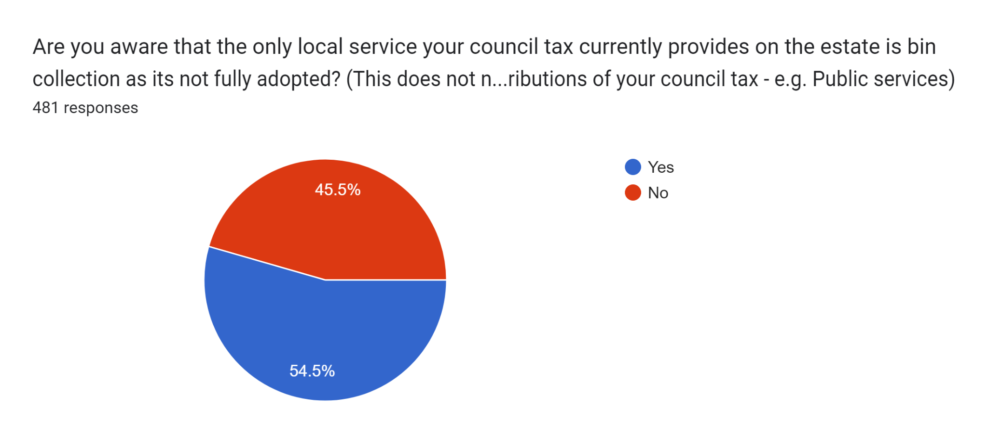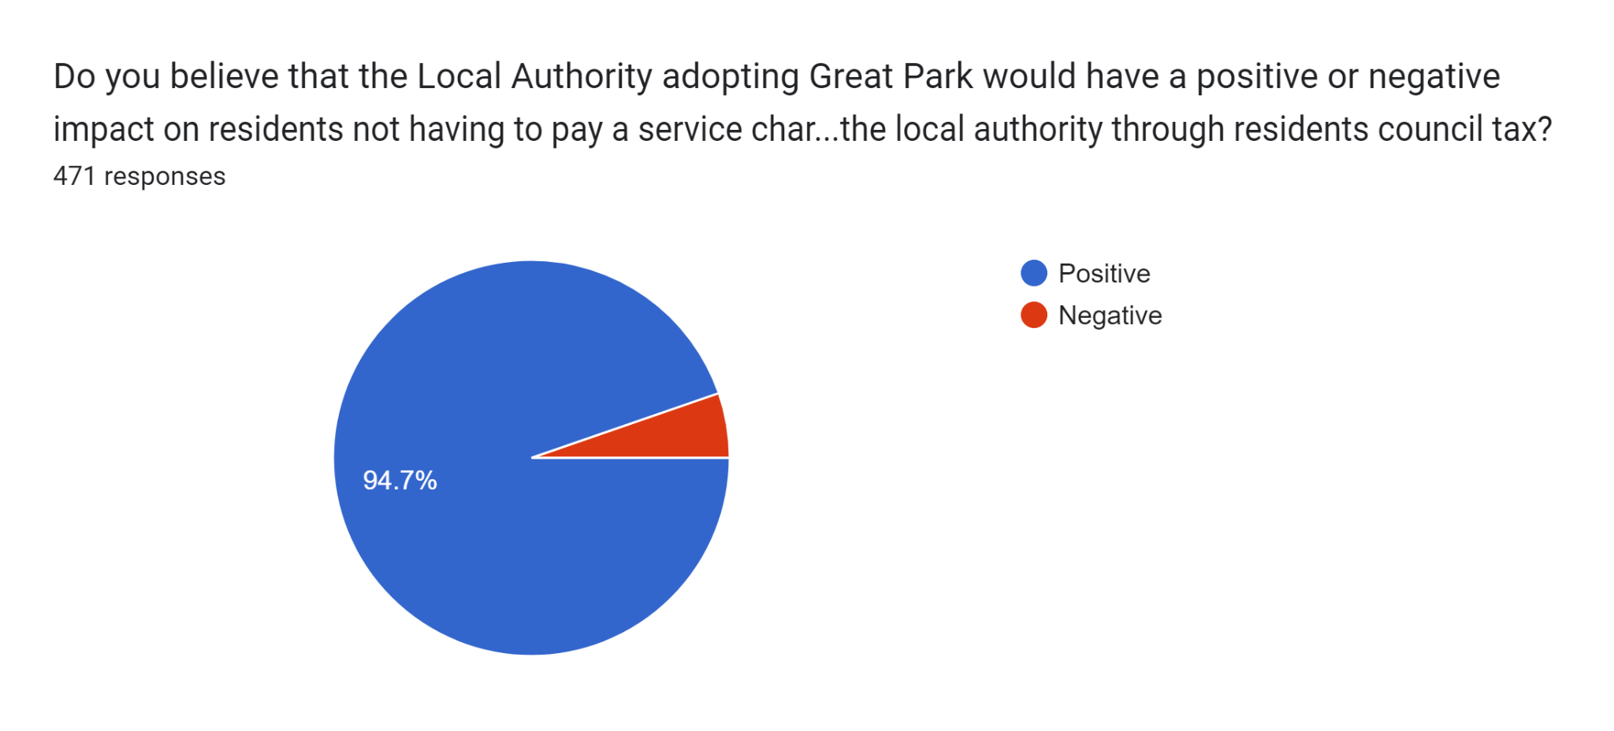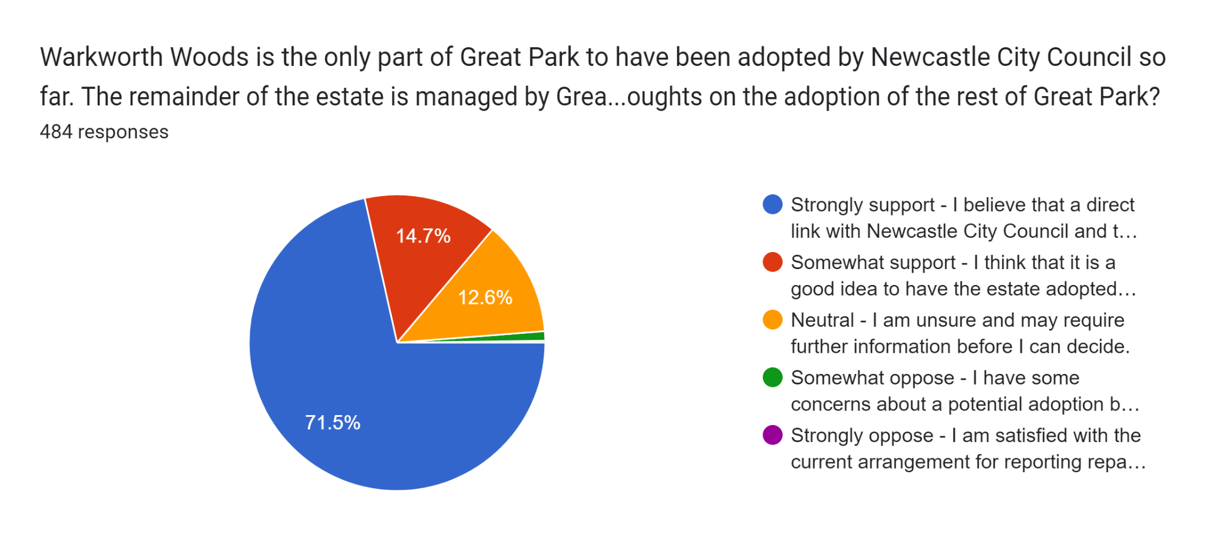
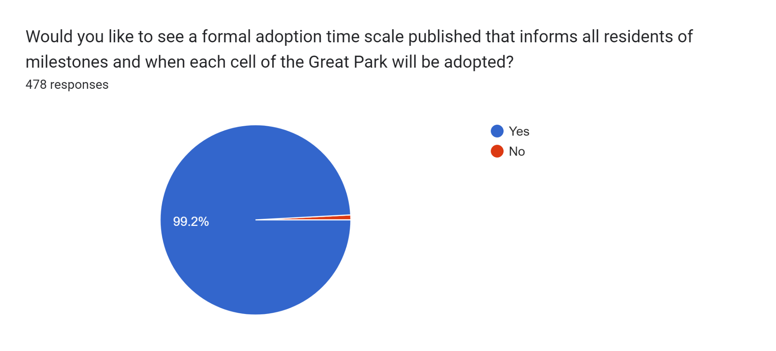

9. GPNA aims and objectives
The aims and objectives of the GPNA are:
a. To promote the interests and wellbeing of residents living in the area of benefit by providing a forum for their views
b. To liaise with all statutory and other responsible bodies to ensure that high standards of estate management are maintained with specific regard to footpaths, roads, street lighting, open spaces, and recreation areas
c. To liaise with Newcastle City Council, Newcastle Great Park developers and the Management Company in order to influence the implementation and development of Newcastle Great Park
d. To improve road and general safety in the area of benefit
e. To monitor closely the safety of roads within and leading to the Development
f. To introduce and maintain a vigorous crime reduction policy
g. To encourage and promote social activities for all age groups
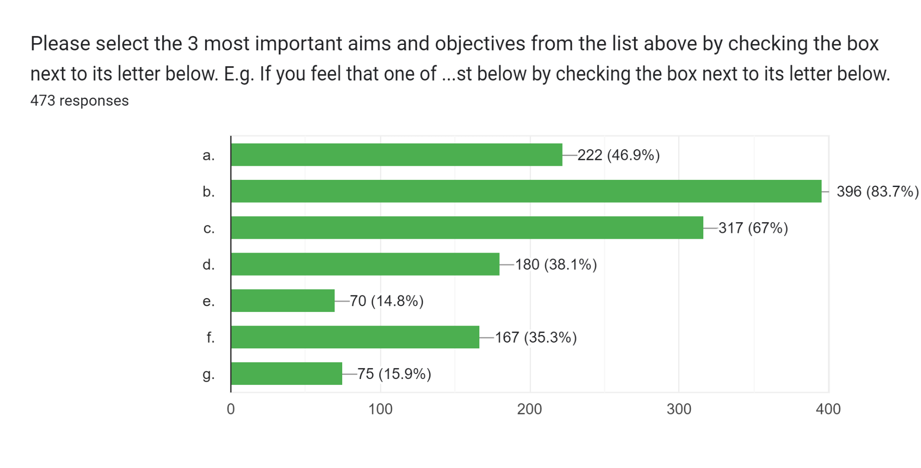

10. General Feedback
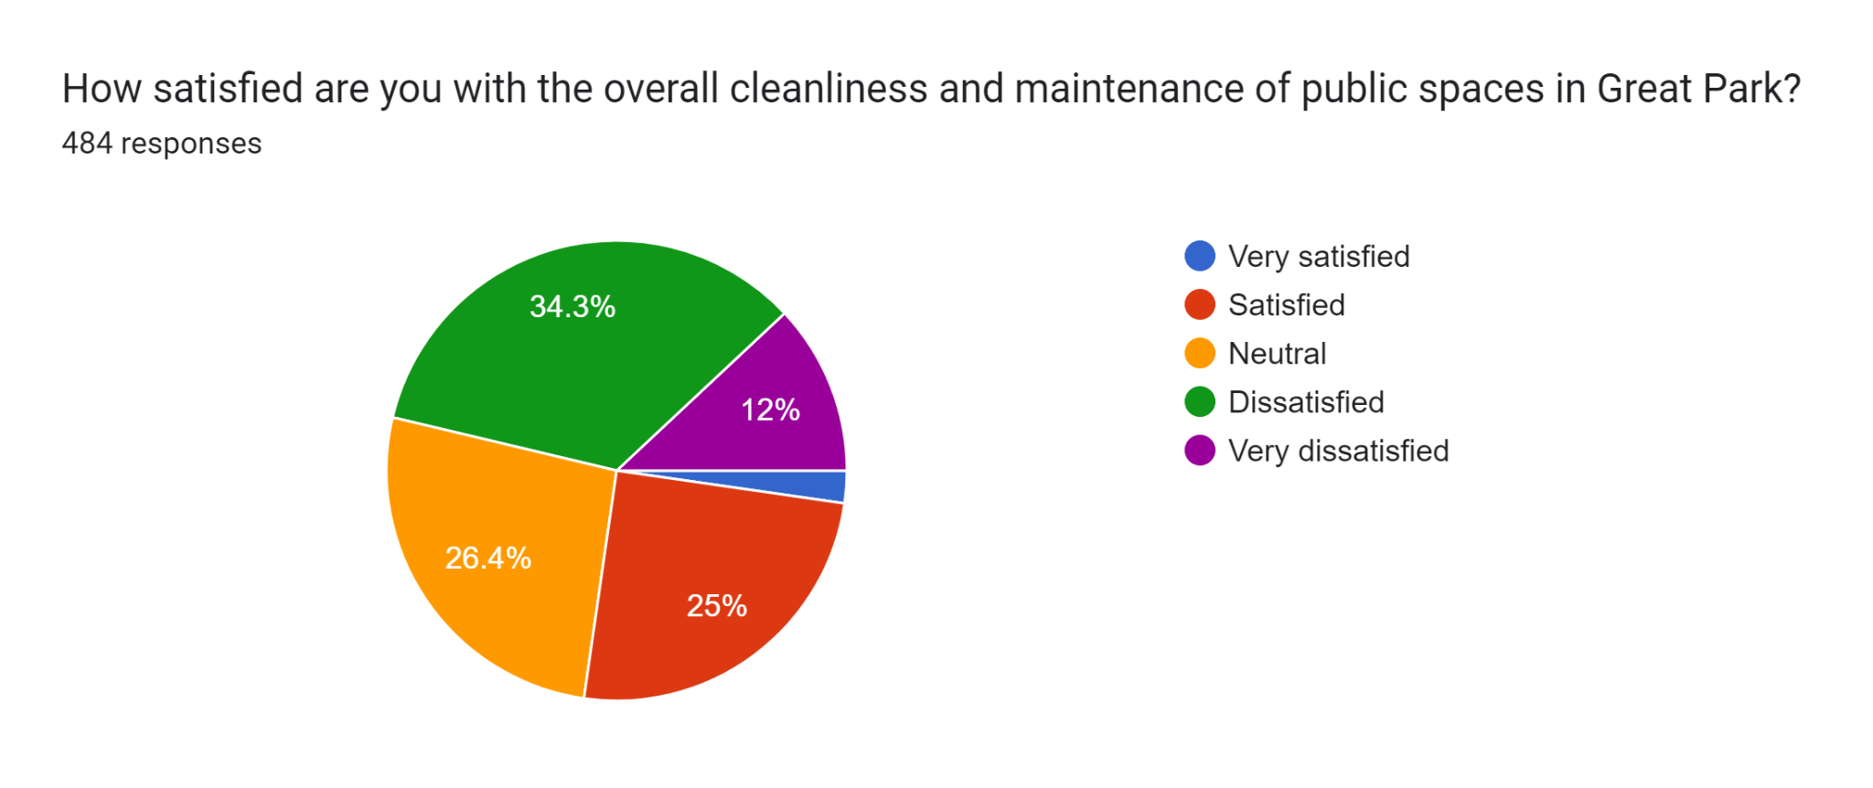
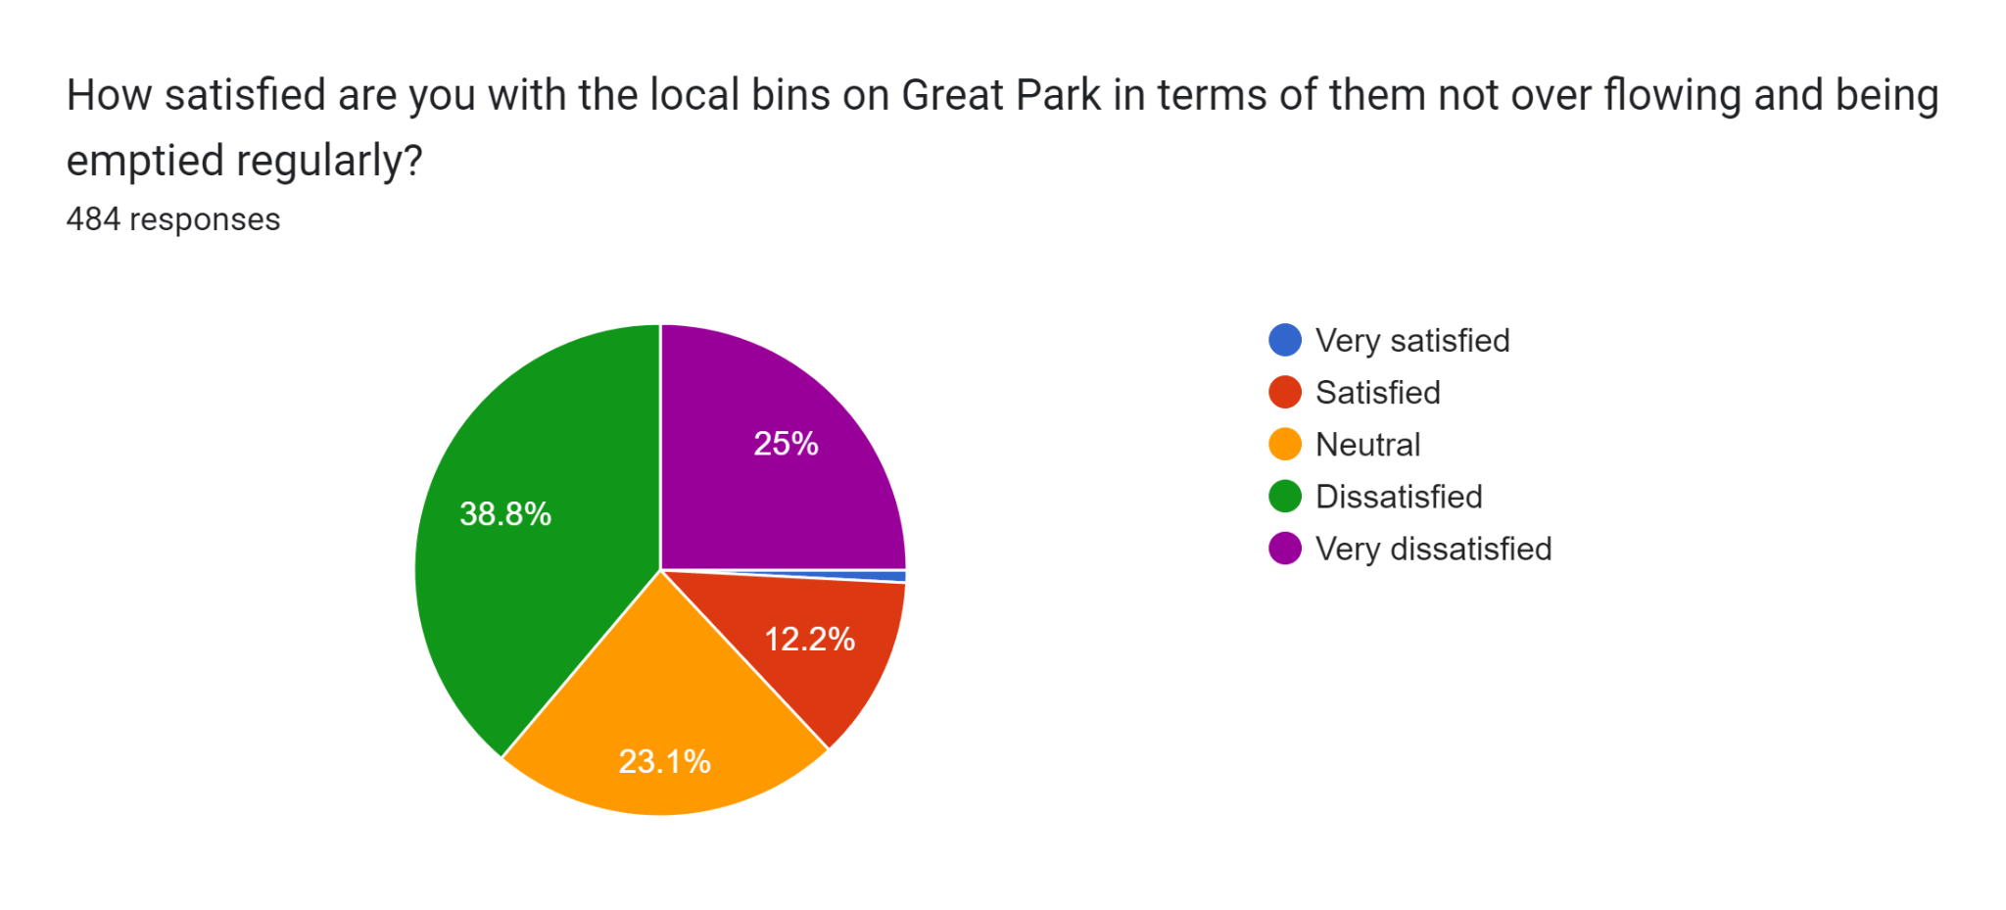
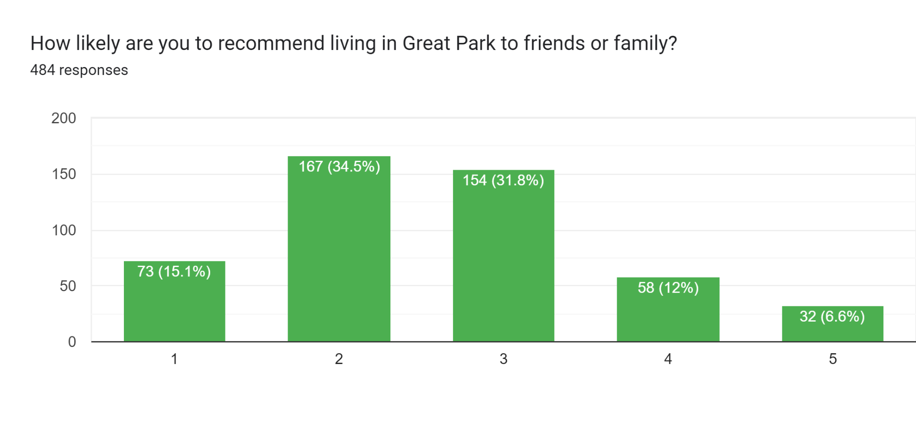
11. Summary of resident feedback for specific areas or facilities in Great Park that were believed to require improved maintenance or attention:

- Unfinished infrastructure: Many residents mentioned unfinished roads, paths, bridges, and landscaping. This creates inconvenience and safety hazards.
- Lighting deficiencies: Inadequate street lighting and broken lights were frequently mentioned, raising concerns about safety and security.
- Bins and litter: Overflowing bins and general litter were prevalent complaints, suggesting a need for better waste management and infrastructure.
- Parks and green spaces: Residents expressed dissatisfaction with the condition of parks, including broken equipment, poor maintenance, and lack of amenities for different age groups.
- Town centre: The state of the town centre, including rendering, cladding, and public spaces, was a major concern for many.

12. Survey Report Conclusion and Recommended Next Steps
Based on the extensive feedback from residents across various aspects of Great Park, several key themes emerge and necessitate immediate action.
1. Communication and Transparency:
- Recommendation: Establish clear communication channels between residents, the Consortium/management company, and local councillors. Regular meetings, informative newsletters, and easily accessible online platforms can foster transparency and address concerns promptly.
2. Service Charge and Accountability:
- Recommendation: Conduct a comprehensive review of the service charge, outlining detailed expenses and justifying its value. Implement transparent budgeting practices and establish resident forums to voice feedback and concerns. Hold the Consortium/management company accountable for service delivery and financial management.
3. Infrastructure Completion and Maintenance:
- Recommendation: Prioritise the completion of unfinished roads, paths, bridges, and landscaping. Allocate resources for regular maintenance of infrastructure, ensuring accessibility and safety for all residents. Address specific concerns highlighted by residents, such as unfinished work, potholes, and lighting deficiencies.
4. Improved Public Transport and Town Centre Revitalization:
- Recommendation: Collaborate with local authorities to improve public transport options, addressing connectivity issues and reliability concerns. Explore partnerships with businesses and community groups to revitalise the town centre, addressing concerns about empty units, high rents, and lack of amenities.
5. Safety and Security:
- Recommendation: Implement traffic calming measures near schools and crossings to address speeding concerns. Improve pedestrian infrastructure with well-marked crossings, completed paths, and adequate lighting. Address safety concerns around parks and play areas, ensuring inclusive equipment and safe spaces for all.
6. Inclusion and Support for SEND Residents:
- Recommendation: Make all community spaces and facilities accessible for residents with SEND needs. Enhance parks and play areas with inclusive equipment and sensory elements. Provide dedicated quiet spaces and sensory rooms within community centres. Offer SEND-friendly activities and groups, and connect families with relevant support services.
7. GPNA Role and Collaboration:
- Recommendation: Strengthen the role of the GPNA as a platform for resident engagement and advocacy. Encourage active participation in discussions and decision-making processes. Foster collaboration between the GPNA, the Consortium/management company, local authorities, and community groups to address resident concerns and implement improvements across Great Park.

Immediate Steps:
- Convene a joint meeting between residents, the Consortium/management company, local councillors, and relevant authorities to address urgent concerns and establish a timeline for action.
- Initiate a comprehensive review of the service charge and infrastructure priorities.
- Develop a communication plan to keep residents informed of progress and next steps.
By prioritising these recommendations and taking immediate action, residents can work together with stakeholders to address their concerns and create a Great Park that is safe, vibrant, and inclusive for all.

