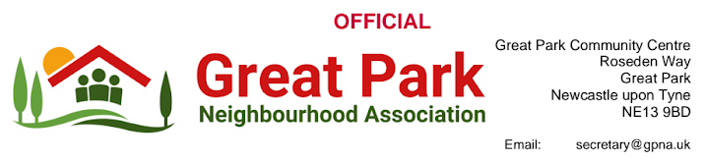
NGP Bus meeting
Date: 30.07.2024
Time: 10.00AM - 11.00AM
Venue: Civic Centre; Barras Bridge; Haymarket; Newcastle upon Tyne
Present | Apologies | Absences
Jamie Robinson (GPNA Chair)  Avaei, Ali (Castle Ward Cllr)  Thom Campion (Castle Ward Cllr)  Herridge, Andrew (Castle Ward Cllr)  Mark Jamieson (TW North East)  Pamela Holmes (Assistant Director Transport NCC & TAB Chair)  Bryan Mullan (NCC)  Dr Gareth Evans (TPS Consultants)  Rob Bettison (TPS Consultants)  Rob Mills (Nexus) | Robin Ashby (Cllr - Parklands Ward)  Pauline Allen (Cllr - Parklands Ward)  Christine Morrissey (Cllr - Parklands Ward)  Donna Rawling (GPNA Committee)
Summary meeting discussion notes:
1. GPNA Chair’s Statement read during the meeting
Good morning,
The Great Park Neighbourhood Association (GPNA) has received an overwhelming volume of concern and disappointment from residents regarding the recent changes to bus routes, particularly those affecting the Q3 service operated by Go North East. Over the past 2 weeks, we have received more than 250 queries and complaints.
The GPNA is deeply troubled by the manner in which these changes have been implemented. The promised consultation, due in early June, has not materialised, in direct contravention of the Public Service Act 2010. Furthermore, Stagecoach’s premature release of information, despite requests to us to withhold it, has undermined the principles of open and transparent engagement.
The Transport North East Charter mandates accurate, accessible, and timely information and consultation with affected communities prior to significant service changes. These requirements have been wholly disregarded.
The GPNA and local councillors were excluded from the transport advisory board meeting where these changes were discussed, effectively removing our community's voice from the decision-making process.
The new routes have severed vital transport links for a considerable portion of our estate, potentially breaching the Equality Act 2010. This has severe implications for residents, including NHS workers, students - particularly 6th formers at Gosforth Academy, parents, and those reliant on public transport to access essential services and employment opportunities in areas such as Gosforth and Jesmond. The drastic reduction in evening and Sunday services impacts approximately 2000 residents.
We are concerned about the potential increase in car usage due to these changes, leading to worsening traffic congestion and higher emissions. The location of new bus stops raises significant safety concerns due to the absence of safe walking routes. We also have reservations about the feasibility of the new Q3 route around Warkworth Woods and Melbury, given potential traffic congestion.
These changes have imposed additional financial burdens on residents who must now seek alternative transport options. We demand access to the cost-benefit analysis that justified these decisions.
Additionally, we require clarification on compliance with S106 agreements and the use of £997,693.23 of Community Infrastructure Levy (CIL) funding allocated for the Park and Ride car park.
Finally, the recent revelation that Go North East was unaware of the changes to routes 49 and X47 highlights a serious breakdown in communication.
It is evident that the consultation mechanism outlined in the Transport North East Charter, which guarantees accurate, accessible, and timely information for passengers, has been completely ignored.
The GPNA expects a full and comprehensive response to these concerns and a commitment to restoring essential bus services to our community.
Discussion Points raised at the meeting:

- The TAB conceded that earlier consultations and engagement should have taken place, and explained that there was unfortunately insufficient time to complete this exercise due to the urgent need to move service levels to a more sustainable level of provision and also deliver increased capacity in time for the start of the new academic year. TAB explained that the process was impacted on the industrial action undertaken by GoNorthEast (GNE) and the need to understand the impact of the school admissions in the area. It was explained that the package of changes which will be introduced in September provides a significant improvement in public transport provision for most residents within Great Park. Several new parts of the estate will now be served by bus and other areas will see improved frequency of service, desired new links to/from Kingston Park whilst retaining comparable journey times to/from the City Centre. We are confident that these improvements will drive modal shift towards more sustainable modes. but also that they can not make any changes to the new routes now in place or hold consultation prior to them taking effect for commercial and financial reasons but will consider enhancements based on the meeting feedback from the GPNA & local councillors alongside their engagement events.
- Following announcement GNE have made a commercial decision to continue with an amended Q3/Q3X. It was agreed that this should address many of the concerns raised by the GPNA chair. The Q3 has been extended on 29th July to run through Warkworth Woods and Melbury on a direct route to the city centre, but that this cannot cross into Great Park over the A1 bridge as it would impact on the new X47 and 49 service routes viability.
- The remaining S106 subsidy funding stated as not being able to sustain the current Q3 service has been diverted to support the new X47 and 49 Stagecoach routes and does not go towards the new Q3 route..
- MP Catherine Mckinnels letter of support (Appendix 1) was shared at the meeting alongside a reminder that our Mayor Kim McGuiness stated that this is an example as to why bus routes need to be brought back under local authority control. (Appendix 2)
- It was nice to see all three Castle Ward councillors present and working together at the meeting and it was good to see that the TAB considered their presence at future TAB meetings so that their constituents' voices will be heard prior to any future changes being announced.
- Despite stating that engagement sessions are occurring over July and August. There is only one confirmed for today 30.07.24 @ the community centre on Great Park from 2pm until 6pm. Further evening ‘engagement sessions’ will be considered after the GPNA chair stated that many residents affected by the changes couldnt access daytime sessions due to work commitments. Future dates will be confirmed in due course.
- The TAB reported that they had little negative feedback over the changes and councillors and the GPNA chair echoed that this was totally different to what we had received. So could residents all please continue to voice their concerns to councillors so that they can raise this with the TAB. The Liberal Democrats figures and feedback was shared regarding the most recent survey regarding the bus services to Great Park. It is worth noting that this survey was circulated in advance of the Q3 announcement and that the survey stated that the Q3 would not operate any more, which is likely to have impacted the feedback. The main figures discussed were that out of 355 responses 300 residents stated that they were sad or very sad about the changes, with 74.9% of respondents stating that they simply wanted the Q3 to do as the Q3x was now going to do with a route from Great Park straight into the city centre after Gosforth. (Appendix 3). This was also raised as an argument by the Chair of GPNA as to why after COVID the bus route was seen as no longer financially viable as many residents change at Regent Centre back onto an Arriva bus to go into Newcastle city centre as pre COVID the route did not go through Jesmond. The TAB confirmed that the continuation of the Q3 servicing Osborne Road was taken as a commercial decision by GNE. TAB confirmed that bus patronage had not returned to 2019 levels pre covid. Note that following the meeting it was confirmed that Q3 patronage figures were 33.6% lower than 2019 after adjustment for industrial action.
- Resident facebook comments were read aloud during the meeting to the TAB regarding negative feedback to highlight the issues and concerns many residents were raising with the bus changes. E.g.
  - Amber Evans-Scott “Oh. this makes me SO angry”
  - Nick Gladdish “A complete sh*t show of the highest order! Thank you so much for NOT serving our area. An absolute joke!! You’ve really thought about your customers haven't you. These services will not work”.
  - Paul James “This is a disgrace, a fait accompli before the bogus “consultation”.
  - Huw Holmes “Go North East and NCC promoting car use by the masses. It’s like a competition to see who can provide the worst service in Newcastle.
  - Gayle Armstrong “I’ve just looked at the Q3 timetable and realised that the Q3x is not going through Jesmond. After the Brandling stop it is direct to town. Pity they’ve done this improvement when the bus no longer serves Great Park!”
  - Edward Gonzales-Harrison “The Q3 bus was ideal for my work. Took me from Great Park to Ouseburn. No need to drive, nice and environmentally friendly. Now it’ll be multiple bus tickets and an absolute faff. No thanks. I’ll be driving. Thanks for this. Great service, not”.
It was noted that there were also positive feedback on social media from residents who were happy with the changes. All parties agreed that there were positives form the addition to a link to Kingston Park.
- The TAB stated that they will consider one earlier 49 and one later bus to be confirmed after receiving the GPNA chair and local councillors feedback.
- The GPNA requested and they stated that they would share the patronage of the current Q3 service which was their main argument for making these changes so quickly and without consultation.
- The GPNA Chair confirmed that the existing and future ‘engagement’ sessions were not a consultation and to simply inform the community of the changes, the reason behind them and that they have not nor would not be using them to consult with residents and that no consultation whatsoever had taken place which is contradictory to their own charter that states this should happen prior to route changes. The engagement sessions will be used to identify any gaps in services which will be considered accordingly.
- The GPNA chair reminded them that the Q3 route to Wallsend had been changed after a petition and concerns were raised in 2022 and that could this be the case with these changes which was denied consideration with regards to consultation taking place if the current service was extended to enable this to happen. TAB confirmed that GNE made a commercial decision to cancel the Q3 route between St Peters Basin – Wallsend in March 2022. Nexus then provided subsidy from July 2022 to restore the withdrawn link using additional funding provided by Central Government. We believe that the new 49/X47 provide a significantly improved level of PT provision for most residents on Great Park. Funding an extension of the Q3 to/from Great Park would not offer good value for money as this would duplicate links which are already provided for by the new 49/X47. Nexus are looking at evening/Sunday provision between NGP – Gosforth High Street, but our initial assessment is that demand for this bespoke link is not sufficient to justify investment in further service provision
- .

Appendices below - *please read / view*

Appendices

Appendix 1:

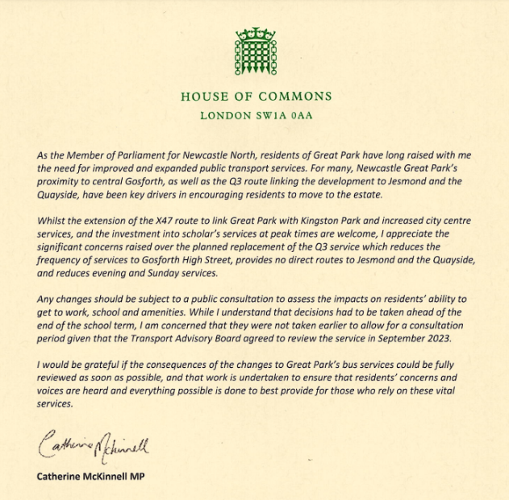

Appendix 2:

Good morning Jamie,

Thank you for your invitation to the Mayor for her to attend a meeting to discuss bus services in Great Park. Unfortunately the Mayor is not available to attend but she has asked me to let you know that she is aware of the situation and is monitoring it with the assistance of her transport team.

We understand that officers from Newcastle City Council and Nexus are fully engaged with the Great Park Consortium over this matter and will attend the meeting on Tuesday. We understand that the Great Park Consortium funds bus services through its private roads through S106 obligations, and that the opening of a new access road has led to the Consortium amending the service through the estate.

The Mayor is supportive of efforts to ensure that people travelling to and from Great Park have the best possible bus accessibility. She has been clear about her intentions to take buses back into public control to provide a better service to residents, though unfortunately a change to the operation of the bus network will take time to put into place.

Kind regards

Jess Mortimer
Mayor’s office
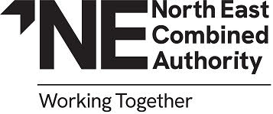

Appendix 3:

Local councillor Liberal Democrats Bus concerns survey launched 25th July 2024 via social media in response to sudden TAB changes by Thom Campion.

Bus concerns Lib Dem report July 2024

Appendix 4:

I would like to add that as chair of the GPNA i am committed to finding the best outcomes for residents on Great Park which includes Warkworth Woods and Melbury, and that to attend this meeting and raise these points I received no financial gain and lost time over the summer holidays with my supportive and loving wife alongside creating memories with my 7 year old daughter, 5 year old son and 22 month year old daughter. This sacrifice has happened because as with many other issues on Great Park I was sold my house on a promise from the developers. A promise that I do not feel is being fulfilled in many areas including this most recent transport issue.

Please support the GPNA, please be active in your community, please show kindness and help one another.

Best wishes,

Jamie Robinson
Chair GPNA

